1. Consider a social networking Web site where sponsors can find families and children to sponsor (the sponsored). Both sponsors and sponsored users maintain some personal information such as first and last name, username, email, phone, date of birth, and description about themselves. The sponsored additionally keep track of their zip code, country and continent. All users maintain a public timeline where they can post and share their activities with friends. Posts include a title, date of posting, and content. Users can search for other users and send friend requests. If accepted as friends, users can post to their friend’s timeline and view their friend’s profiles. Users can comment on any post. Comments are similar to posts, but are only visible for a given post, they are not visible in the timeline. Sponsors can set up an account from where to draw funds to donate to their sponsored friends. Accounts are described by account numbers, type (debit card, credit card, bank account), expiration date, security code, routing number, and bank name. Users can donate by clicking on one of several donate buttons with fixed amounts of $1, $5, $10, $20 displayed on the profile of a sponsored user. Additionally users can donate by clicking on like buttons on posts or comments. Each like donates 10 cents from a sponsor user to a sponsored user. Users can view their donation history is various histograms. Users can remove their accounts in which case their personal profile information is removed as well. Posts and donation history are never removed. Create a UML diagram that captures the data and relations described above. Make sure to show cardinality, name your relations, remove redundant and inadequate relationships and attributes, annotate composition, aggregation, and/or generalization.
2. Consider the following UML diagram and provide the equivalent relational model. Do not use the enum data type supported by some databases (use a separate table instead). Use the multiple tables inheritance strategy. Implement all relevant constraints to enforce referential integrity, composition, aggregation, and generalization.  
   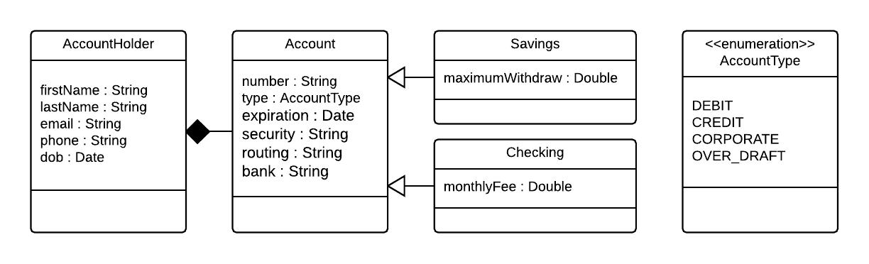
3. Given the following relational model and use cases, write SQL statements that implement the use cases  
   1. Relational Model  
        
      CREATE TABLE Sponsor (  
       username VARCHAR (50) NOT NULL,  
       CONSTRAINT pk_Sponsor PRIMARY KEY (username)  
      );  
        
      CREATE TABLE Sponsored (  
       username VARCHAR (50) NOT NULL,  
       CONSTRAINT pk_Sponsored PRIMARY KEY (username)  
      );  
        
      CREATE TABLE Donation (  
       sponsorUsername VARCHAR (50),  
       sponsoredUsername VARCHAR (50),  
       amount double,  
       date Date NULL,  
       frequency VARCHAR (50),  
       CONSTRAINT fk_Donation_sponsorUserName FOREIGN KEY (sponsorUsername)  
       REFERENCES Sponsor(username),  
       CONSTRAINT fk_Donation_sponsoredUserName FOREIGN KEY (sponsoredUsername)  
       REFERENCES Sponsored(username),  
       CONSTRAINT fk_Donation_frequency FOREIGN KEY (frequency)  
       REFERENCES FrequencyType(type)  
      );  
        
      CREATE TABLE FrequencyType (  
       type VARCHAR (50),  
       CONSTRAINT pk_FrequencyType PRIMARY KEY (type)  
      );  
        
      INSERT INTO FrequencyType (type) VALUES (‘ONE_TIME’);  
      INSERT INTO FrequencyType (type) VALUES (‘DAILY’);  
      INSERT INTO FrequencyType (type) VALUES (‘WEEKLY’);  
      INSERT INTO FrequencyType (type) VALUES (‘MONTHLY’);  
      INSERT INTO FrequencyType (type) VALUES (‘YEARLY’);  
        
      CREATE TABLE Friend (  
       sponsorUsername VARCHAR (50),  
       sponsoredUsername VARCHAR (50),  
       CONSTRAINT pk_Friend PRIMARY KEY (sponsorUsername, sponsoredUsername),  
       CONSTRAINT fk_Friend_sponsorUsername FOREIGN KEY (sponsorUsername)  
       REFERENCES Sponsor(username),  
       CONSTRAINT fk_Friend_sponsoredUsername FOREIGN KEY (sponsoredUsername)  
       REFERENCES Sponsored(username)  
      );
   2. Use Cases
      1. Username “tom” makes a one time donation of $25 to username “alice” today
      2. Username “bob” sets up a monthly recurring donation to “edward” of $5 a month
      3. Unfriend usernames “charlie” and “dan”
      4. Increase username’s “bob” recurring donations to “edward” to weekly and to $10
      5. Find the most common donation frequency type
      6. Find the top 10 sponsors with the most friends
      7. Find the top 10 sponsoreds with the most one time donations
      8. Find all sponsors at the daily frequency who donated more than $1000 total for the current year